**DAILY ONLINE ACTIVITIES SUMMARY**

|  |  |  |  |  |  |  |  |  |
| --- | --- | --- | --- | --- | --- | --- | --- | --- |
| **Date:** | **07-07-2020** | | | | | **Name:** | **Deeksha D Poojary** | |
| **Sem & Sec** | **VIII Semester & A Section** | | | | | **USN:** | **4AL16CS026** | |
| **Online Test Summary** | | | | | | | | |
| **Subject** | | **-** | | | | | | |
| **Max. Marks** | | **-** | | **Score** | | | **-** | |
| **Certification Course Summary** | | | | | | | | |
| **Course** | **Introduction to Amazon Elastic Compute Cloud (EC2)** | | | | | | | |
| **Certificate Provider** | | | **Amazon Web Service** | | **Duration** | | | **10 minutes** |
| **Coding Challenges** | | | | | | | | |
| **Problem Statement: Write a program for superperfect number** | | | | | | | | |
| **Status: COMPLETED** | | | | | | | | |
| **Uploaded the report in Github** | | | | | **YES** | | | |
| **If yes Repository name** | | | | | **deekshapoojari** | | | |
| **Uploaded the report in slack** | | | | | **YES** | | | |

Online Test Details:

NIL

Certification Course 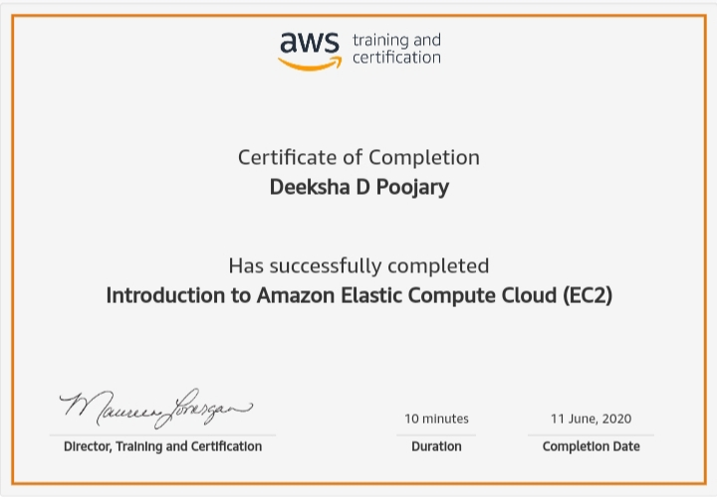Coding Challenges Details:

|  |
| --- |
|  |
|  |
|  |
|  |
|  |
|  |
|  |
|  |
|  |
|  |
|  |
|  |
|  |
|  |
|  |
|  |
|  |
|  |
|  |
|  |
|  |
|  |
|  |
|  |
|  |
|  |
|  |
|  |
|  |
|  |
|  |
|  |
|  |
|  |
|  |
|  |
|  |
|  |
|  |
|  |
|  |
|  |
|  |
|  |
|  |
|  |
|  |
|  |
|  |
|  |
|  |
|  |
|  |
|  |

**Program1:**

|  |  |
| --- | --- |
|  |  |

#include<stdio.h>

//function to find the sum of divisors of num

int divisorsum(int n){

   int sum = 0; // intialising the sum

   for (int i=1; i*i <= n; ++i){

      if (n%i == 0) { // find the sum of divisors

         if (i == (n/i))

            sum += i;

         else

            sum += (i + n/i);

      }

   }

   return sum;

}

int main() {

   int n = 16;

   int n1 = divisorsum(n);

   if(2*n == divisorsum(n1)){

      printf("The number %d is a superperfect number", n);

   } else{

      printf("The number %d is not a superperfect number", n);

   }

   return 0;

}